## Objective: Design wireframe for your semester project based on web design principles(login, registration, homepage)

# Code :-

## (Home Page) :-

<!DOCTYPE html>

<html lang="en">

<head>

<meta charset="UTF-8">

<meta name="viewport" content="width=device-width, initial-scale=1.0">

<title>Competitive Programming Club</title>

</head>

<body>

<header>

<nav>

<div class="container">

<h1>Competitive Programming Club</h1>

<ul>

<li><a href="#">Home</a></li>

<li><a href="#">About Us</a></li>

<li><a href="#">Events</a></li>

<li><a href="#">Resources</a></li>

<li><a href="#">Contact</a></li>

</ul>

</div>

</nav>

</header>

<div class="slider">

<img src="image1.jpg" alt="Image 1">

<img src="image2.jpg" alt="Image 2">

<img src="image3.jpg" alt="Image 3">

</div>

<script>

let currentSlide = 0;

const slides = document.querySelectorAll('.slider img');

const totalSlides = slides.length;

function showSlide(index) {

slides.forEach((slide) => {

slide.style.display = 'none';

});

slides[index].style.display = 'block';

}

function nextSlide() {

currentSlide = (currentSlide + 1) % totalSlides;

showSlide(currentSlide);

}

function prevSlide() {

currentSlide = (currentSlide - 1 + totalSlides) % totalSlides;

showSlide(currentSlide);

}

showSlide(currentSlide);

setInterval(nextSlide, 5000);

</script>

</body>

</html>

## Output :-

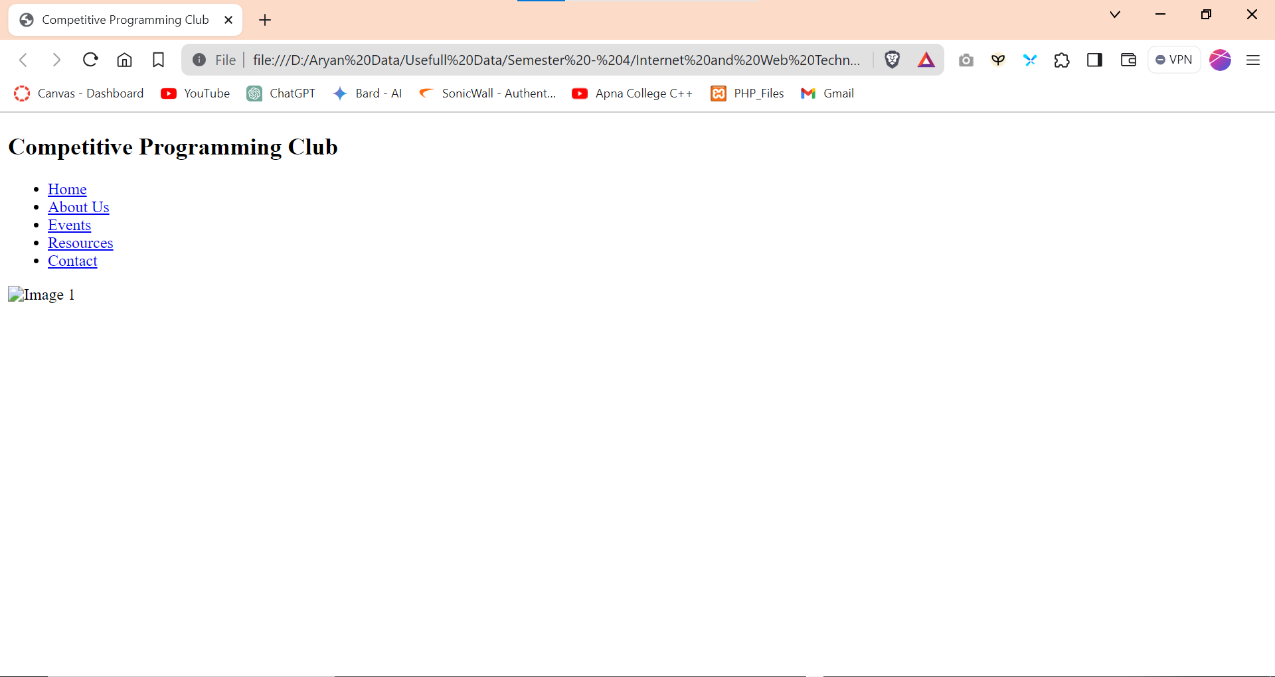

**Login Form :-**

<!DOCTYPE html>

<html lang="en">

<head>

<meta charset="UTF-8">

<meta name="viewport" content="width=device-width, initial-scale=1.0">

<title>Log In - CP Club ICT MU</title>

</head>

<body>

<div class="wrapper">

<div class="form-box login">

<h2>Log In</h2>

<form action="#">

<div class="input-box">

<input type="text" name="" id="" required>

<label for="">User Name</label>

<i class='bx bxs-user'></i>

</div>

<div class="input-box">

<input type="password" name="" id="" required>

<label for="">Password</label>

<i class='bx bxs-lock'></i>

</div>

<button class="btn" type="submit">

Log In

</button>

<div class="logreg-link">

<p>Don't Have An Account ? <a href="#" class="register-link">Sign Up</a></p>

</div>

</form>

</div>

</div>

<script src="../js/login.js"></script>

</body>

</html>

**Output :-**

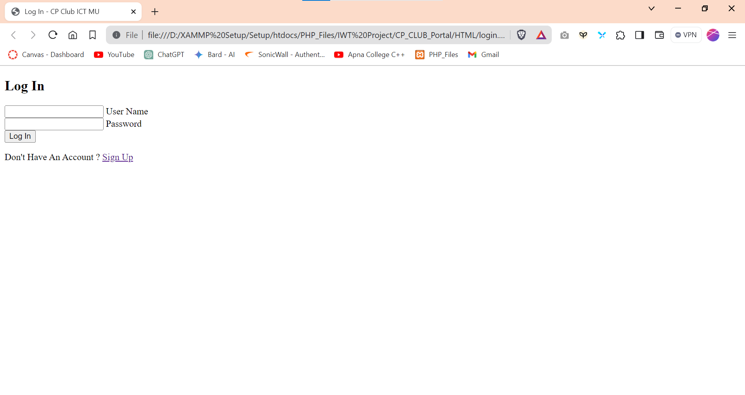

**Registration Form:-**

<!DOCTYPE html>

<html lang="en">

<head>

<meta charset="UTF-8">

<meta http-equiv="X-UA-Compatible" content="IE=edge">

<meta name="viewport" content="width=device-width, initial-scale=1.0">

<title>Responsive Registration Form</title>

</head>

<body>

<div class="container">

<header>Registration</header>

<form action="#">

<div class="form first">

<div class="details personal">

<span class="title">Personal Details</span>

<div class="fields">

<div class="input-field">

<label>Full Name</label>

<input type="text" placeholder="Enter your name" required>

</div>

<div class="input-field">

<label>Institute Email</label>

<input type="email" placeholder="Enter your institute email" required>

</div>

<div class="input-field">

<label>Personal Mail</label>

<input type="email" placeholder="Enter your personal email" required>

</div>

<div class="input-field">

<label>Phone Number</label>

<input type="tel" placeholder="Enter your phone number" required>

</div>

<div class="input-field">

<label>Department</label>

<select required>

<option disabled selected>Select department</option>

<option value="CE-AI">CE-AI</option>

<option value="ICT">ICT</option>

<option value="CE">CE</option>

<option value="BIO INFORMATICS">BIO INFORMATICS</option>

<option value="IT">IT</option>

<option value="BCA">BCA</option>

<option value="MCA">MCA</option>

</select>

</div>

<div class="input-field">

<label>Batch Year</label>

<input type="number" placeholder="Enter your batch year" required>

</div>

<div class="input-field">

<label>Enrollment No</label>

<input type="text" placeholder="Enter your enrollment number" required>

</div>

</div>

</div>

</div>

<div class="buttons">

<button class="register">

<span class="btnText">Register</span>

<i class="uil uil-navigator"></i>

</button>

<button class="alreadyRegistered">

<span class="btnText">Already Registered</span>

<i class="uil uil-navigator"></i>

</button>

</div>

</form>

</div>

<script src="./Form.js"></script>

</body>

</html>

**Output :-**

